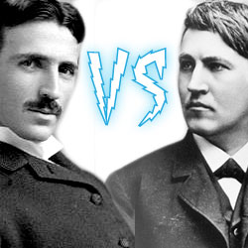
Tesla vs. Edison Debate Score Chart

You are the impartial judges. Each student will have 2 minutes to make their arguments. Look for the following items as you watch the debate. The student should address the topic in a clear and convincing manner, use facts that support the topic, and uses the time given effectively.
For each pair of students, mark the column of the student you think did a better job with a check.

 | Tesla | Edison
Round 1
Round 2
Round 3
Round 4
Round 5
Round 6
Round 7
Round 8
Round 9
Round 10
Round 11
Round 12
Round 13
Round 14
Round 15

