Use the following databases to learn more: Biography in Context, Science in Context, Science Flix, and World Book Student
 | Tesla | Edison
Born
Died
Nickname
Education
Number of Patents
Most Important Inventions
Controversies
Quote

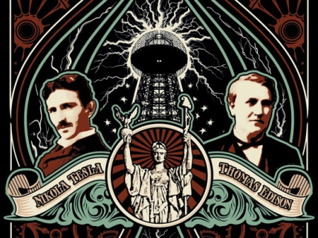
War of the Currents!

AC Current
How does it work?

Benefits
Downsides

DC Current
How does it work?

Benefits

Downsides

