You and three of your closest friends are flying on a once in a lifetime trip to take part in the finish line festivities of the famous Iditarod dog sledding race. The race is about a 1000 mile journey that ends in Nome, Alaska.
You are flying over the beautiful and serene Alaskan wilderness when the pilot suddenly ejects from the plane. As you watch his graceful parachuted descent, you begin to scream. Many thoughts race through your mind – “Are we going to crash?” “Did I kiss my parents before I left?” “Did I remember to put on clean undies?” It is in that moment that you jump into action! Your friends are immobilized and in a state of shock, the plane is heading for the ground, and no one that knows how to fly it.
You make a quick decision to try and land the plane in the clearing below. After all, you are the top scorer on the most realistic flight simulator game ever. If only the airplane’s controller had “X’s” and “O’s” like your controller at home, you are sure you would be safe. It takes you a few moments, but you do manage to level out the plane and head for the clearing at a gentle angle. Thank you, Mrs. Washington, for those geometry lessons in math class!
As the plane approached the ground, your friends begin to wake up from their catatonic shock only to look at you with wide eyes and scream. You keep your head and with only one or two small – okay really big and scary – bounces land the plane in the clearing.
After your racing heart settles down, and your complete breakdown subsides, your brain begins to function once again. The first thing you try to do is call 911 then your mommy, but there is no cell service in the middle of the arctic, and you do not have a satellite phone. One of your friends suggests using the radio to call for help, but it is no use. The radio was broken on the first impact with the ground. You were stranded and no one was coming to help. In the back of your mind, you hold a small hope that the plane had a black box which will signal your location, but you do not think that is the case. Since you do not want to have your friends endure any more shock for today, you did not mention your black box hopes.
You remember reading an article by Danielle Hill about Nome, Alaska. In the article she states, “The city of Nome, Alaska, is in a tundra environment. The tundra climate is midway between sub-arctic and ice cap climates. Tundra conditions exist throughout much of Greenland, in parts of Alaska, northern Canada and in northern Russia. Typically, a tundra will only exist between latitudes of 60 and 75 degrees North. The proximity of a body of water also helps form the tundra climate, as it keeps temperatures from dropping even lower. Aside from the extreme temperatures found in the tundra, the precipitation is quite extreme; with only 6 to 10 inches of rain or snow per year, the tundra is as dry as the driest desert” (Hill, Danielle, USA Today).

After agonizing moments, the severity of the situation sinks in and you take inventory of any supplies on the plane that may help you.
- You are alone near Nome, Alaska with four of your friends.
- You have about six and a half hours of daylight each day.
- You have two cases of bottled water.
- You have a first aid kit with gauze, band aids, rubbing alcohol, medical tape, an ace bandage, and tweezers.
- You have several blankets each.
- You have airplane snacks – peanuts and pretzels.
- You each have your suitcase with the clothes you packed for your trip. Fortunately, you and your friends’ moms made sure you had enough clothes to dress in layers similar to Randy, Ralphie’s brother in the movie A Christmas Story.

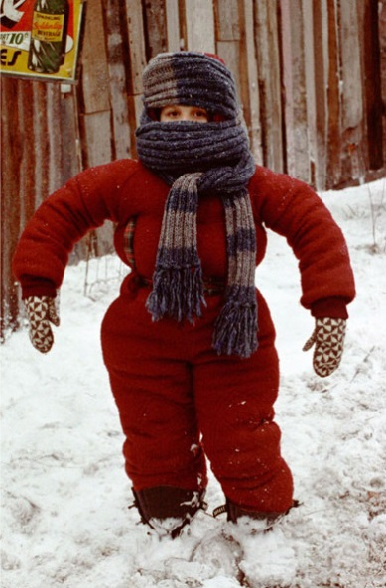

Now it is up to you to survive!

You have your background story. You need to figure out how to survive in the arctic.
Research questions:

For each question you are responsible for the following:
- A bibliographic citation (made using easybib)
- A direct quotation from the source
- The same quotation paraphrased
- At least a 50-60 word response using the quotation and your research to answer the question

- Where is the Nome, Alaska?
- What is tundra?
- What is the best type of clothing to wear in the arctic?
- How much water do you need to drink each day to survive in the arctic?
- What types of food can you find in the arctic?
- What is the temperature of Nome, Alaska in the day and in the night during March?
- What type of shelter do you need to survive in the arctic?
- How do you protect yourself from snowstorm and the temperature?
- What animals live in the arctic and are they edible?
- What is hyperthermia, what are the symptoms, and how can you protect yourself from it?

