Rising 8th Grade Summer Reading 2014
Students Must Read 1 book from the list:
Tears of a Tiger by Sharon Draper
After a car accident kills Robert, Andy's best friend and teammate on the Hazelwood High Tigers, Andy doesn't know if he can go on. He's consumed with guilt for driving the night of the accident after a long evening of drinking and partying. With perceptiveness and compassion, Sharon M. Draper portrays an African-American teenager who feels driven to consider suicide in the wake of a devastating tragedy.

8th Grade Bites by Heather Brewer
Vlad has to keep his vampire urges under control while dealing with the pressures of middle school. Thirteen-year-old Vladimir Tod really hates junior high. Bullies harass him, the principal is dogging him, and the girl he likes prefers his best friend. Oh, and Vlad has a secret: His mother was human, but his father was a vampire. With no idea of the extent of his powers, Vlad struggles daily with his blood cravings and his enlarged fangs. When a substitute teacher begins to question him a little too closely, Vlad worries that his cover is about to be blown. But then he faces a much bigger problem: He’s being hunted by a vampire killer.

The Selection by Kiera Cass
For thirty-five girls, the Selection is the chance of a lifetime. The opportunity to escape the life laid out for them since birth. To be swept up in a world of glittering gowns and priceless jewels. To live in a palace and compete for the heart of gorgeous Prince Maxon. But for America Singer, being Selected is a nightmare. It means turning her back on her secret love with Aspen, who is a caste below her. Leaving her home to enter a fierce competition for a crown she doesn't want. Living in a palace that is constantly threatened by violent rebel attacks. Then America meets Prince Maxon. Gradually, she starts to question all the plans she's made for herself—and realizes that the life she's always dreamed of may not compare to a future she never imagined.

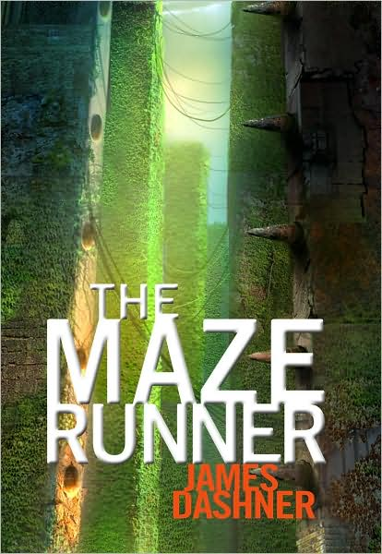
Maze Runner by James Dashner
When Thomas wakes up in the lift, the only thing he can remember is his name. He’s surrounded by strangers—boys whose memories are also gone. Outside the towering stone walls that surround the Glade is a limitless, ever-changing maze. It’s the only way out—and no one’s ever made it through alive. Then a girl arrives. The first girl ever. And the message she delivers is terrifying.
Remember. Survive. Run.

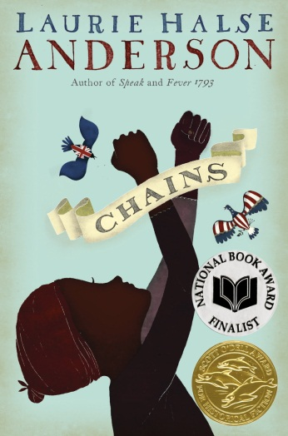
Chains by Laurie Halse Anderson
As the Revolutionary War begins, thirteen-year-old Isabel wages her own fight...for freedom. Promised freedom upon the death of their owner, she and her sister, Ruth, in a cruel twist of fate become the property of a malicious New York City couple, the Locktons, who have no sympathy for the American Revolution and even less for Ruth and Isabel. When Isabel meets Curzon, a slave with ties to the Patriots, he encourages her to spy on her owners, who know details of British plans for invasion. She is reluctant at first, but when the unthinkable happens to Ruth, Isabel realizes her loyalty is available to the bidder who can provide her with freedom.

