Rising 6th grade Reading 2014
Students Must Read 1 book from the list:
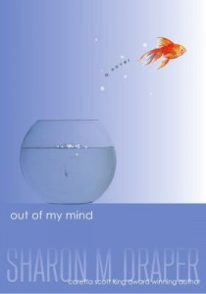
Out of My Mind by Sharon Draper
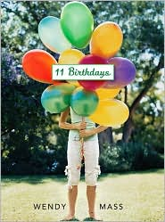
Melody is not like most people. She cannot walk or talk, but she has a photographic memory; she can remember every detail of everything she has ever experienced. She is smarter than most of the adults who try to diagnose her and smarter than her classmates in her integrated classroom—the very same classmates who dismiss her as mentally challenged, because she cannot tell them otherwise. But Melody refuses to be defined by cerebral palsy. And she’s determined to let everyone know it…somehow. In this breakthrough story—reminiscent of The Diving Bell and the Butterfly—from multiple Coretta Scott King Award-winner Sharon Draper, readers will come to know a brilliant mind and a brave spirit who will change forever how they look at anyone with a disability.
11 Birthdays by Wendy Mass
It's Amanda's 11th birthday and she is super excited---after all, 11 is so different from 10. But from the start, everything goes wrong. The worst part of it all is that she and her best friend, Leo, with whom she's shared every birthday, are on the outs and this will be the first birthday they haven't shared together. When Amanda turns in for the night, glad to have her birthday behind her, she wakes up happy for a new day. Or is it? Her birthday seems to be repeating iself. What is going on?! And how can she fix it? Only time, friendship, and a little luck will tell. . .

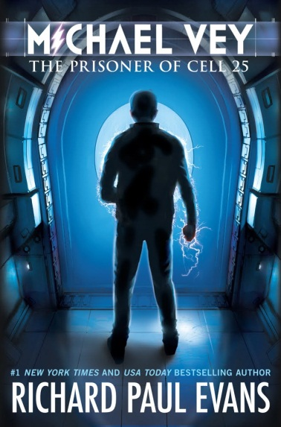
Michael Vey: The Prisoner of Cell 25 by Richard Paul Evans
To everyone at Meridian High School, fourteen-year-old Michael Vey is nothing special, just the kid who has Tourette’s syndrome. But in truth, Michael is extremely special—he has electric powers. Michael thinks he is unique until he discovers that a cheerleader named Taylor has the same mysterious powers. With the help of Michael’s friend, Ostin, the three of them set out to discover how Michael and Taylor ended up with their abilities, and their investigation soon brings them to the attention of a powerful group who wants to control the electric teens—and through them, the world.
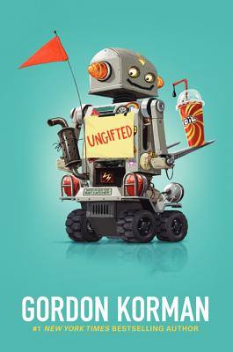
Ungifted by Gordan Korman
When Donovan Curtis pulls a major prank at his middle school, he thinks he’s finally gone too far. But thanks to a mix-up by one of the administrators, instead of getting in trouble, Donovan is sent to the Academy of Scholastic Distinction, a special program for gifted and talented students. Although it wasn’t exactly what Donovan had intended, the ASD couldn’t be a more perfectly unexpected hideout for someone like him. But as the students and teachers of ASD grow to realize that Donovan may not be good at math or science (or just about anything), he shows that his gifts may be exactly what the ASD students never knew they needed.

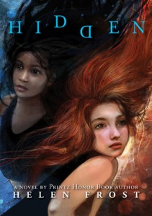
Hidden by Helen Frost
When Wren Abbott and Darra Monson are eight years old, Darra's father steals a minivan. He doesn't know that Wren is hiding in the back. The hours and days that follow change the lives of both girls. Darra is left with a question that only Wren can answer. Wren has questions, too. Years later, in a chance encounter at camp, the girls face each other for the first time. They can finally learn the truth—that is, if they’re willing to reveal to each other the stories that they’ve hidden for so long. Told from alternating viewpoints, this novel-in-poems reveals the complexities of memory and the strength of a friendship that can overcome pain.

