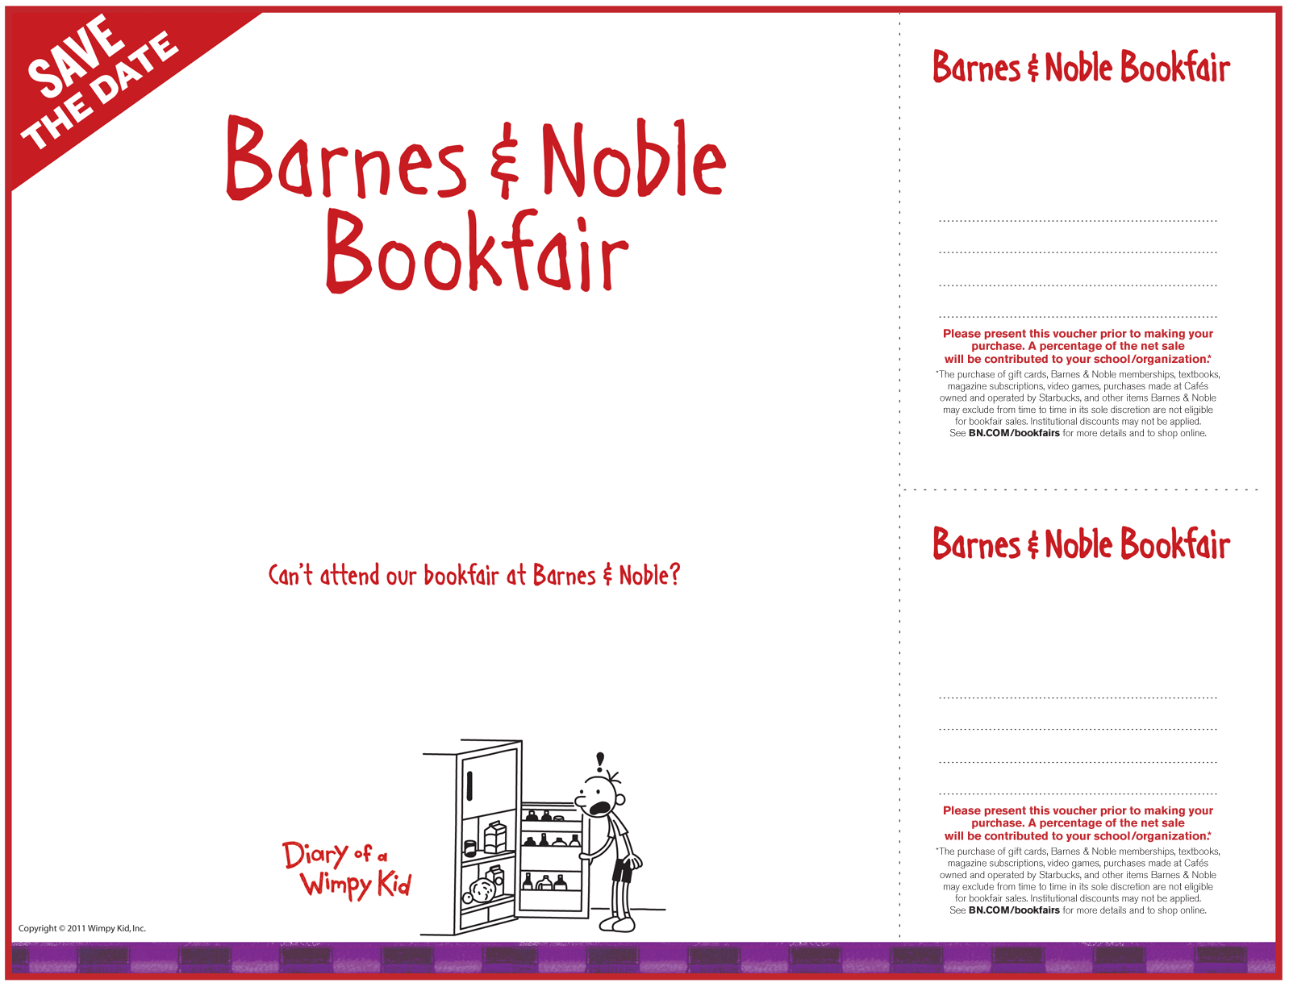

**April 16 & 17, 2011**

**1350 Scenic Hwy, Snellville**

Orchestra Performance

Chorus Performance

Tea time with Ms. Spraggs

Hunger Games and Twilight trivia

Cookie decorating

Great prizes and more!!!

Visit B**N.COM/bookfairs** to support us online from

04/10/11 to 04/17/11by entering Bookfair ID **10441210** at checkout.

**Grace Snell Middle School**

**April 16 & 17, 2011**

supporting

**Grace Snell Middle School**

**10441210**

**1350 Scenic Hwy, Snellville**

**Barnes & Noble**

supporting

**Grace Snell Middle School**

**1350 Scenic Hwy, Snellville**

**Barnes & Noble**

**April 16 & 17, 2011**

**10441210**