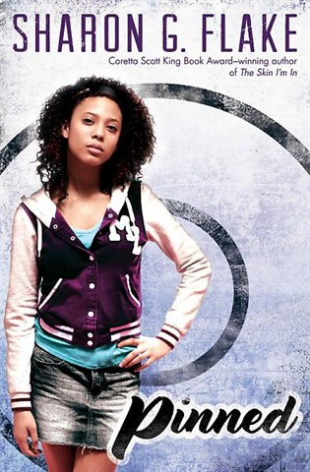
8th grade Summer Reading 2013
Pinned by Sharon Flake
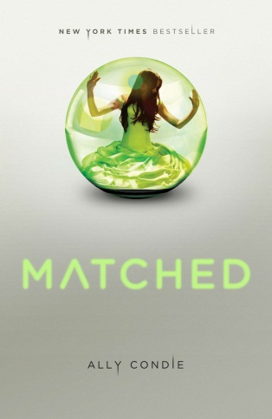
Award-winning author, Sharon G. Flake, presents a powerful novel about a teen boy and girl, each tackling disabilities. Autumn and Adonis have nothing in common and everything in common. Autumn is outgoing and has lots of friends. Adonis is shy and not so eager to connect with people. But even with their differences, the two have one thing in common--they're each dealing with a handicap. For Autumn, who has a learning disability, reading is a painful struggle that makes it hard to focus in class. But as her school’s most aggressive team wrestler, Autumn can take down any problem. Adonis is confined to a wheelchair. He has no legs. He can't walk or dance. But he’s a strong reader who loves books. Even so, Adonis has a secret he knows someone like Autumn can heal. In time, Autumn and Adonis are forced to see that our greatest weaknesses can turn into the assets that forever change us and those we love. Told in alternating voices, Takedown explores issues of self-discovery, friendship, and what it means to be different.
Matched by Allie Condie
Cassia has always trusted the Society to make the right choices for her: what to read, what to watch, what to believe. So when Xander's face appears on-screen at her Matching ceremony, Cassia knows he is her ideal mate . . . until she sees Ky Markham's face flash for an instant before the screen fades to black. The Society tells her it's a glitch, a rare malfunction, and that she should focus on the happy life she's destined to lead with Xander. But Cassia can't stop thinking about Ky, and as they slowly fall in love, Cassia begins to doubt the Society's infallibility and is faced with an impossible choice: between Xander and Ky, between the only life she's known and a path that no one else has dared to follow.
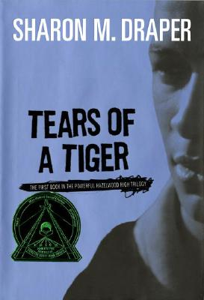
Tears of a Tiger by Sharon Draper
When Gerald was a child he was fascinated by fire. But fire is dangerous and powerful, and tragedy strikes. His substance-addicted mother is taken from him. Then he loses the loving generosity of a favorite aunt. A brutal stepfather with a flaming temper and an evil secret makes his life miserable. The one bright light in Gerald's life is his little half sister, Angel, whom he struggles to protect from her father, Jordan Sparks, who abuses her, and from their mother, whose irresponsible behavior forces Gerald to work hard to keep the family together.
As a teenager, Gerald finds success as a member of the Hazelwood Tigers basketball team, while Angel develops her talents as a dancer. Trouble still haunts them, however, and Gerald learns, painfully, that young friends can die and old enemies must be faced. In the end he must stand up to his stepfather alone in a blazing confrontation.
Eighth Grade Bites by Heather Brewer
Thirteen-year-old Vladimir Tod really hates junior high. Bullies harass him, the principal is dogging him, and the girl he likes prefers his best friend. Oh, and Vlad has a secret: His mother was human, but his father was a vampire. With no idea of the extent of his powers, Vlad struggles daily with his blood cravings and his enlarged fangs. When a substitute teacher begins to question him a little too closely, Vlad worries that his cover is about to be blown. But then he faces a much bigger problem: He’s being hunted by a vampire killer

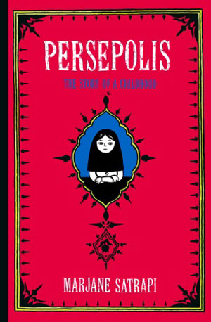
Persepolis: The Story of a Childhood by Marjane Satrapi (non-fiction)
Persepolis paints an unforgettable portrait of daily life in Iran: of the bewildering contradictions between home life and public life and of the enormous toll repressive regimes exact on the individual spirit. Marjane’s child's-eye-view of dethroned emperors, state-sanctioned whippings, and heroes of the revolution allows us to learn as she does the history of this fascinating country and of her own extraordinary family. Intensely personal, profoundly political, and wholly original, Persepolis is at once a story of growing up and a stunning reminder of the human cost of war and political repression. It shows how we carry on, through laughter and tears, in the face of absurdity. And, finally, it introduces us to an irresistible little girl with whom we cannot help but fall in love.

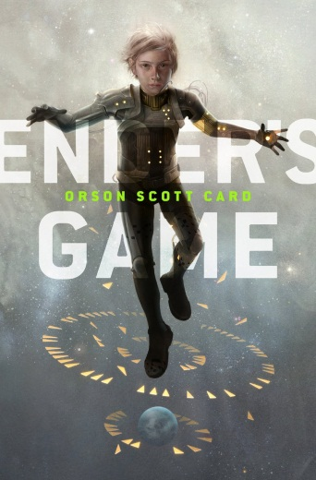
Ender’s Game by Orson Scott Card (classic)
In order to develop a secure defense against a hostile alien race's next attack, government agencies breed child geniuses and train them as soldiers. A brilliant young boy, Andrew "Ender" Wiggin is drafted to the orbiting Battle School for rigorous military training. Ender's skills make him a leader in school and respected in the Battle Room, where children play at mock battles in zero gravity. Yet growing up in an artificial community of young soldiers, Ender suffers greatly from isolation, rivalry from his peers, pressure from the adult teachers, and an unsettling fear of the alien invaders. Is Ender the general Earth needs? But Ender is not the only result of the genetic experiments. The war with the Buggers has been raging for a hundred years, and the quest for the perfect general has been underway for almost as long. Ender's two older siblings are every bit as unusual as he is, but in very different ways. Between the three of them lie the abilities to remake a world. If the world survives, that is.

