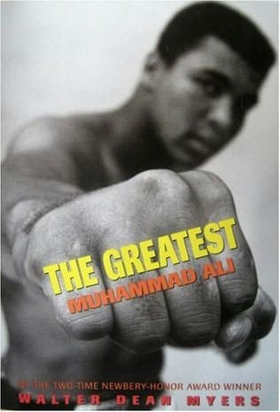
7th grade Summer Reading 2013
The Greatest: Muhammad Ali by Walter Dean Myers (non-fiction)
An introduction to Ali's life from his childhood to the present day, focusing on his career and the controversies surrounding him. Both his talent in the boxing ring and his showmanship earned him international fame, while his refusal to accept the stereotypical role of a black athletic star in the 1960s and his membership in the Nation of Islam brought him notoriety. Myers interweaves fight sequences with the boxer's life story and the political events and issues of the day. He doesn't shy away from reporting on the brutality of the sport and documents the toll it has taken on its many stars. Ample black-and-white photographs of the subject in and out of the ring illustrate the book.

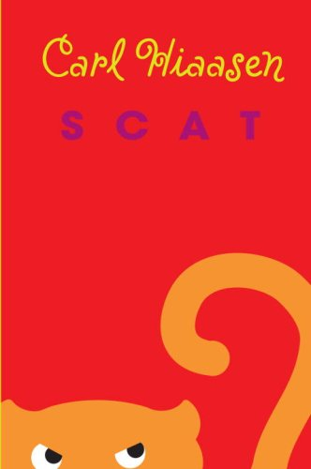
Scat by Carl Hiaasen
Bunny Starch, the most feared biology teacher ever, is missing. She disappeared after a school field trip to Black Vine Swamp. And, to be honest, the kids in her class are relieved.
But when the principal tries to tell the students that Mrs. Starch has been called away on a "family emergency," Nick and Marta just don't buy it. No, they figure the class delinquent, Smoke, has something to do with her disappearance.
And he does! But not in the way they think. There's a lot more going on in Black Vine Swamp than any one player in this twisted tale can see. And Nick and Marta will have to reckon with an eccentric eco-avenger, a stuffed rat named Chelsea, a wannabe Texas oilman, a singing substitute teacher, and a ticked-off Florida panther before they really begin to see the big picture.

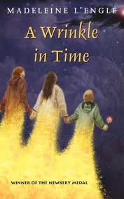
A Wrinkle in Time by Madeline L’Engle (classic)
It was a dark and stormy night; Meg Murry, her small brother Charles Wallace, and her mother had come down to the kitchen for a midnight snack when they were upset by the arrival of a most disturbing stranger.
"Wild nights are my glory," the unearthly stranger told them. "I just got caught in a downdraft and blown off course. Let me sit down for a moment, and then I'll be on my way. Speaking of ways, by the way, there is such a thing as a tesseract."
A tesseract (in case the reader doesn't know) is a wrinkle in time. To tell more would rob the reader of the enjoyment of Miss L'Engle's unusual book. A Wrinkle in Time, winner of the Newbery Medal in 1963, is the story of the adventures in space and time of Meg, Charles Wallace, and Calvin O'Keefe (athlete, student, and one of the most popular boys in high school). They are in search of Meg's father, a scientist who disappeared while engaged in secret work for the government on the tesseract problem.

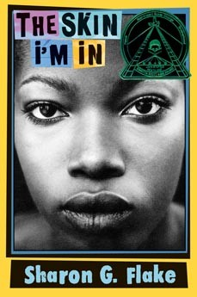
The Skin I’m In by Sharon Flake
Seventh-grader Maleeka Madison is miserable when a new teacher comes to her depressed inner-city school. Miss Saunders evidently is rich, self-assured in spite of the white birthmark across her black skin, and prone to getting into kids' faces about both their behavior and their academic potential. Black and bright, Maleeka is so swamped by her immediate problems that Miss Saunders's attentions nearly capsize her stability. The girl's mother has just emerged from a two-year period of intense mourning for her dead husband, during which time her daughter has provided her with physical and moral support with no adult assistance. At school, Maleeka endures mean-spirited teasing about the darkness of her skin and her unstylish clothing. She seeks solace in writing an extended creative piece, at Miss Saunders's instigation, and also in the company of a powerful clique of nasty girls. Told in Maleeka's voice, this first novel bristles with attitude that is both genuine and alarming. The young teen understands too well that her brains aren't as valuable as the social standing that she doesn't have. In the end, she is able to respond positively to Miss Saunders; she also becomes socially anointed through the affections of the most popular boy in the school. This message rings true in spite of the fact that Maleeka's salvation isn't exactly politically correct. Young teens will appreciate Flake's authenticity and perhaps realize how to learn from Maleeka's struggle for security and self-assurance.
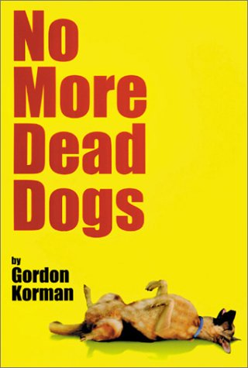
No More Dead Dogs by Gordon Korman
Nobody understands Wallace Wallace. This reluctant school football hero has been suspended from the team for writing an unfavorable book report of Old Shep, My Pal. But Wallace won`t tell a lie-he hated every minute of the book! Why does the dog in every classic novel have to croak at the end? After refusing to do a rewrite, his English teacher, who happens to be directing the school play Old Shep, My Pal, forces him go to the rehearsals as punishment. Although Wallace doesn`t change his mind, he does end up changing the play into a rock-and-roll rendition, complete with Rollerblades and a moped!

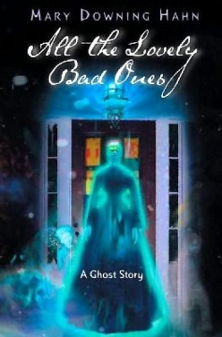
All the Lovely Bad Ones by Mary Downing Hahn
Travis and his sister, Corey, can't resist a good trick. When they learn that their grandmother's quiet Vermont inn, where they're spending the summer, has a history of ghost sightings, they decide to do a little "haunting" of their own. Before long, their supernatural pranks have tourists flocking to the inn, and business booms.
But Travis and Corey soon find out that they aren't the only ghosts at Fox Hill Inn. Their thoughtless games have awakened something dangerous, something that should have stayed asleep. Can these siblings lay to rest the ghosts they’ve stirred?

