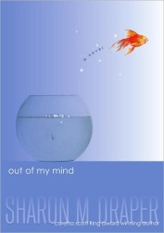
6th grade summer reading 2013
Out of My Mind by Sharon Draper
Melody is not like most people. She cannot walk or talk, but she has a photographic memory; she can remember every detail of everything she has ever experienced. She is smarter than most of the adults who try to diagnose her and smarter than her classmates in her integrated classroom—the very same classmates who dismiss her as mentally challenged, because she cannot tell them otherwise. But Melody refuses to be defined by cerebral palsy. And she’s determined to let everyone know it…somehow. In this breakthrough story—reminiscent of The Diving Bell and the Butterfly—from multiple Coretta Scott King Award-winner Sharon Draper, readers will come to know a brilliant mind and a brave spirit who will change forever how they look at anyone with a disability.
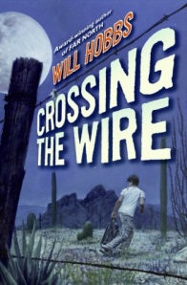
Crossing the Wire by Will Hobbs
When falling crop prices threaten his family with starvation, fifteen-year-old Victor Flores heads north in an attempt to "cross the wire" from Mexico into the United States so he can find work and send money home. But with no coyote money to pay the smugglers who sneak illegal workers across the border, Victor must struggle to survive as he jumps trains, stows away on trucks, and hikes grueling miles through the Arizona desert. Victor's journey is fraught with danger, freezing cold, scorching heat, hunger, and dead ends. It's a gauntlet run by millions attempting to cross the border. Through Victor's often desperate struggle, Will Hobbs brings to life one of the great human dramas of our time.

11 Birthdays by Wendy Mass
It's Amanda's 11th birthday and she is super excited---after all, 11 is so different from 10. But from the start, everything goes wrong. The worst part of it all is that she and her best friend, Leo, with whom she's shared every birthday, are on the outs and this will be the first birthday they haven't shared together. When Amanda turns in for the night, glad to have her birthday behind her, she wakes up happy for a new day. Or is it? Her birthday seems to be repeating itself. What is going on?! And how can she fix it? Only time, friendship, and a little luck will tell. . .

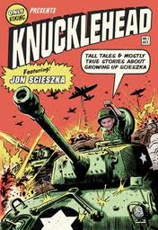
Knucklehead: Tall Tales and Almost True Stories of Growing up Scieszka by Jon Scieszka
How did Jon Scieszka get so funny, anyway? Growing up as one of six brothers was a good start, but that was just the beginning. Throw in Catholic school, lots of comic books, lazy summers at the lake with time to kill, babysitting misadventures, TV shows, jokes told at family dinner, and the result is Knucklehead. Part memoir, part scrapbook, this hilarious trip down memory lane provides a unique glimpse into the formation of a creative mind and a free spirit.

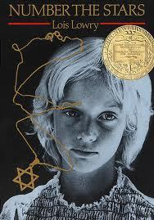

Number the Stars by Lois Lowry (classic)
As the German troops begin their campaign to “relocate” all the Jews of Denmark, Annemarie Johansen’s family takes in Annemarie’s best friend, Ellen Rosen, and conceals her as part of the family. Through the eyes of ten-year-old Annemarie, we watch as the Danish Resistance smuggles almost the entire Jewish population of Denmark, nearly seven thousand people, across the sea to Sweden. The heroism of an entire nation reminds us that there was pride and human decency in the world even during a time of terror and war.

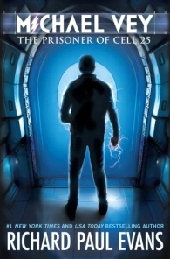

Michael Vey: The Prisoner of Cellblock 25 by Richard Paul Evans
To everyone at Meridian High School, fourteen-year-old Michael Vey is nothing special, just the kid who has Tourette’s syndrome. But in truth, Michael is extremely special—he has electric powers. Michael thinks he is unique until he discovers that a cheerleader named Taylor has the same mysterious powers. With the help of Michael’s friend, Ostin, the three of them set out to discover how Michael and Taylor ended up with their abilities, and their investigation soon brings them to the attention of a powerful group who wants to control the electric teens—and through them, the world.

